Project Design

of

**Bio-Inspired Swarm Robotics Simulation Using Python**

**AINT 44052**

**Intelligent Autonomous Robotics**

**H.M. Sudith Amarasinghe**

**CS/2018/003**

**1. System Architecture**

**1.1 Overview**

Using bio-inspired algorithms, a number of robots, or booids, move and interact in a 2D simulation environment. The simulation environment, the boid model, the control algorithms, and the user interface are the primary parts.

**1.2 Components**

* **Robot Model (Boid):** Each boid has a position, velocity, and acceleration. The boids use simple movement and sensor capabilities to interact with their environment.
* **Environment:** A 2D plane with static obstacles. The environment is represented using a grid where each cell can be either empty or occupied by an obstacle.
* **Control Algorithm:** Implements the bio-inspired flocking behavior using three main rules: alignment, cohesion, and separation.

**2. Flowcharts and Diagrams**

**2.1 Flowchart for Boid Behavior:**

1. **Initialize Boid:**

- Set initial position, velocity, and acceleration.

1. **Edges Check:**

- Wrap around edges if the boid goes out of bounds.

1. **Flocking Behavior:**

- Calculate alignment, cohesion, and separation forces.

- Apply these forces to update the boid’s acceleration.

1. **Update Position:**

- Update the boid’s velocity and position based on acceleration.

1. **Render Boid:**

- Draw the boid on the screen.

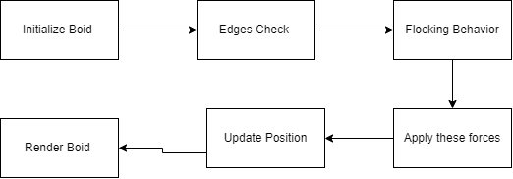

-Simple flowchart for the system-

**3. Implementation Details**

**3.1 Classes and Functions:**

**Boid Class:**

* __init__: Initializes the boid with random position and velocity.
* update: Updates the boid’s position and velocity.
* apply_force: Applies a force to the boid’s acceleration.
* align, cohesion, separation: Calculate alignment, cohesion, and separation forces.

**Simulation Class:**

* __init__: Initializes the simulation environment.
* run: Main loop to update and render boids.

**3.2 Pseudocode:**

